Git overflow

Git is version control system, helps you to keep track of code change, used to collaborate on code. System for managing our files.
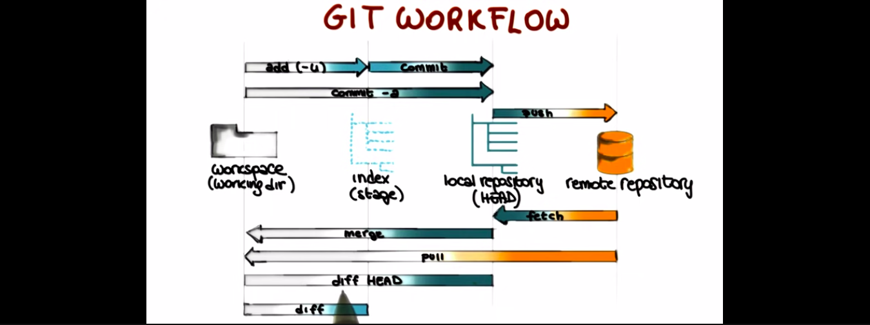
The 4 most funamental elemet in git workflow are workspace, index, local repository and remote repository.
Workspace is local directory(working dir), index is called stage, local directory, we refer as head when we use different command and remote directory.
- Git clone
gives access to remote repository and it creates copy of repository in workspace.
- Git add
adds file from workspace to index. The file is staged in index which is marked to be committed but yet not committed.
- Git commit
The files in tthe index arent committed so we use git commit. All the changes in files are committed to local repository.
- Git commit(-a)
It does the work of git add and git commit at once onlly when the files in workspace is aready part of repository. It doesnt work if the files are new.
- Git push
It pushes all files from local directory to remote directory. It is visible to everyone who have access to remote repository.
- Git fetch
Get files from remote repository to local repository not to the workspace.
- Git merge
Takes changes in local repository to workspace… The files will be updated in workspace with what was in the remote repository.
- Git pull
Files directly from remote repository to workspace.
- Git diff head
Once we fetch files from remote repository to local repository we can use command git diff head which gives the difference between files in workspace and files in local repository.
Based on differences it is decided whether to merge or not.
- Git diff
Tells difference between files in working space and files that are staged in index. It tells what you can add to the stage for further commit that you havent done.
- Git branch:- create new branch.
- Git stash :- remove all local changes before you commit.

